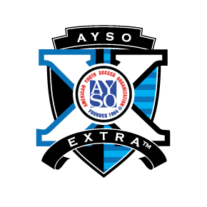
Area 8C Extra Program - Come join the fun!!!
This program offers additional play for players on select region(s) teams to compete against other select region(s) teams while still playing as part of the primary program.

AYSO EXTRA is a PROGRESSIVE PLAYER PROGRAM designed to provide a more challenging level of soccer for AYSO players who have the interest, skills and abilities. It enhances that player's experience and individual growth through soccer while retaining the spirit of and organization membership in AYSO.

We are playing currently in U10 and U12 Divisions for boys and girls in selected Regions.
(Current Teams in Regions 158,448,459 and 708)

Check with Region you are registering with if interested in this program.

Other question please send to Extra Area Coordinator - extra@ayso8c.org

